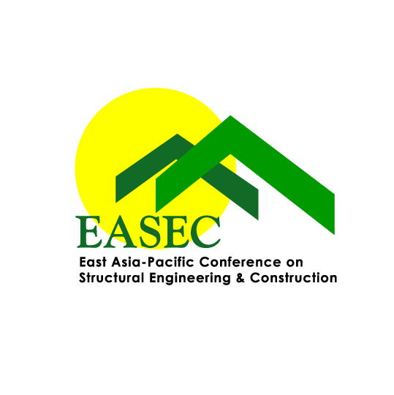 | The East Asia-Pacific Conference on Structural Engineering & Construction (EASEC)  International Steering Committee
EASEC Young Researcher/Engineer Award - NOMINATION FORM

Nominee Information:
Title*: Prof./Dr./Mr./Mrs./Ms. Family Name: First Name:
Position: Institution/Organization:
Address:
Tel: Fax: Email:
The nominee is of age below 35 (as of the first date of the conference) YES , NO
The nominee has agreed to this nomination. YES , NO
The nominee’s contributions in the field of Structural Engineering and Construction (not more than 300 words)

List of awards have been received by the nominee (use additional sheets if necessary)

Please provide a list of 3 best outputs of the nominee (next page). Outputs including, but not limited to:
- Journal paper published as first and/or corresponding author;
- Funded research project as principal investigator; and
- Project involved (a short paragraph of not more than 80 words to show your contributions in the project).

The nominee’s 3 best works
1.
2.
3.

Signature of nominee |  | Date
* Please delete as appropriate

Important Notes:
The EASEC Young Researcher/Engineer Award is to be awarded to a young researcher/engineer (age below 35 as of the first date of the conference) from the Asia-Pacific region who has shown potential for great future achievements in the area of structural engineering and construction through research, development and/or practice. The award will be presented during EASEC-18, Chiang Mai, Thailand (November 13-15, 2024). The completed nomination form must be submitted via email to Associate Professor Vinh Dao (v.dao@uq.edu.au) – Secretary General, EASEC International Steering Committee by August 1, 2024.

