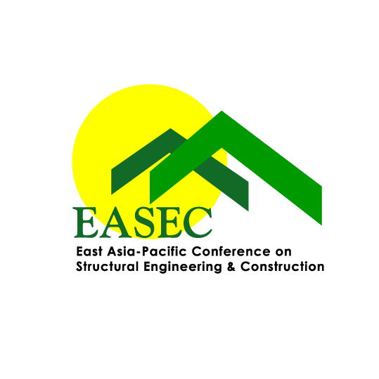 | The East Asia-Pacific Conference on Structural Engineering & Construction (EASEC)  International Steering Committee  EASEC18 BEST YOUNG RESEARCHER’S PAPER AWARD FORM

Applicant Information:
Title: Family Name: First Name:
Position: Institution/Organization:
Address:
Tel: Email:

I, hereby, confirm that:
- I am eligible for the EASEC-18 Best Young Researcher’s Paper Award. And,
- I am the first author and presenter of the following full paper:
Please insert the Paper ID and Full Title here

Signature of Applicant: |  | Date:

Important Notes:
The EASEC-18 Best Young Researcher’s Paper Award is to recognize the best EASEC-18 paper of young researchers (of age below 35 years as of the first date of the conference). To be considered for this award, applicants must be the first author and presenter, and submit their full paper as per conference deadlines. The completed nomination form must be submitted via email to Associate Professor Vinh Dao (v.dao@uq.edu.au) – Secretary General, EASEC International Steering Committee by August 1, 2024. The award will be presented during EASEC-18, Chiang Mai, Thailand (November 13-15, 2024).

